GIT Repository Information:

URL:

In order to setup the Project you need to complete the tasks as follows:

1. GIT Checkout
2. Gradle Build
3. Import project to eclipse IDE.

**Pre requisites**

1. GIT Bash 1.9.5+ (GIT Client)
2. Gradle 4+
3. Proxy Server Host and Port (Only if jar library outside walgreens network is needed)

**Setup Windows environment**

**Step 1 Checkout project**

1. Open Git Bash client and use cd command to navigate to folder where the project will be created.

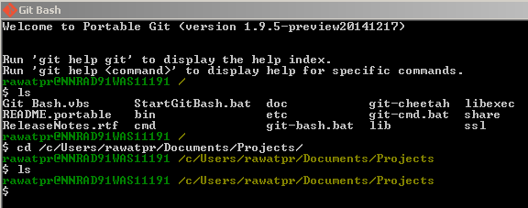

1. Use git command with clone subcommand using the url of the project. The Credentials to the repository will be asked during this step so make sure you have this information.

$ git clone URL

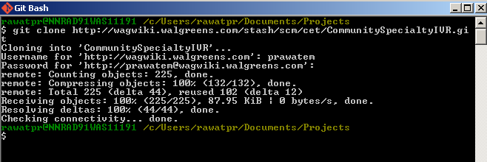

Now you should be able to build the project. Make sure that the work folder is not empty and files build.gradle and gradle.properties exists.

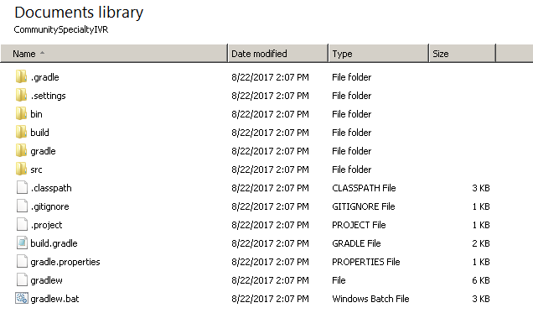

**Step 2 Build project**

1. Setup gradle command on Windows command line.
   1. Unzip gradle software in the directory of your preference which we will call as GRADLE_HOME.
   2. Create new Environment System Variable named GRADLE_HOME until your gradle installation folder as follows:
      1. Rise Wizard by typing:

SystemPropertiesAdvanced.exe

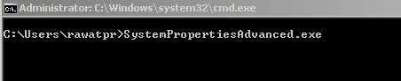

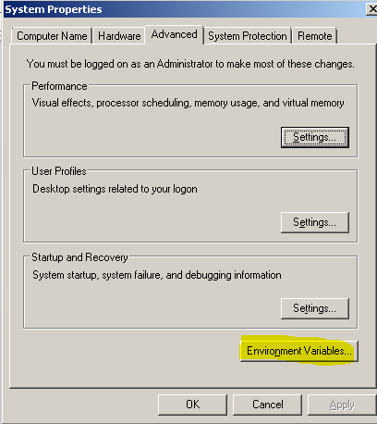



* 1. Set the environment variable PATH to GRADLE_HOME\bin as follows:

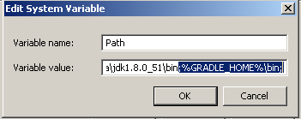

* 1. Check the gradle version with the command above:

C:\>gradle --version

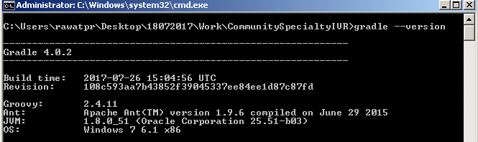

1. Use gradle to build the project

**Step 3 Import Project to Eclipse IDE**

1. You might use eclipse gradle command as follows:

C:\>gradle -Dhttps.proxyHost=*.*.*.* -DproxyPort=8080 eclipse

Above command is required first time set up only. From next time you can just use below:

C:\>gradle eclipse

1. Open eclipse IDE.

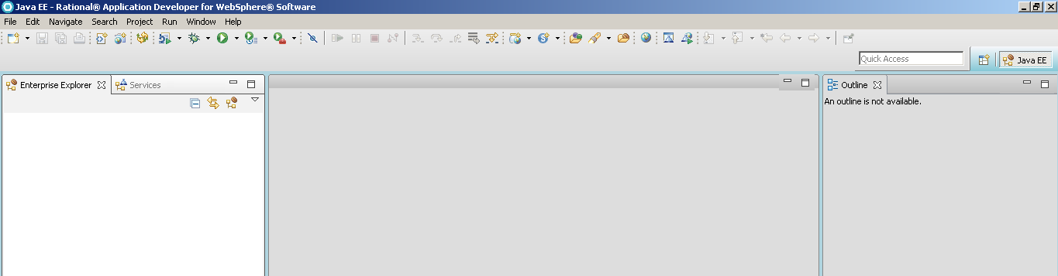

1. Use the “Import” Option and navigate to the project’s directory.

